5. Create a web dashboard to take user input for scheduling the pump controller (date & time). store the data in the Cloudant DB.

you can use Form Nodes in dashboard nodes to take user input.

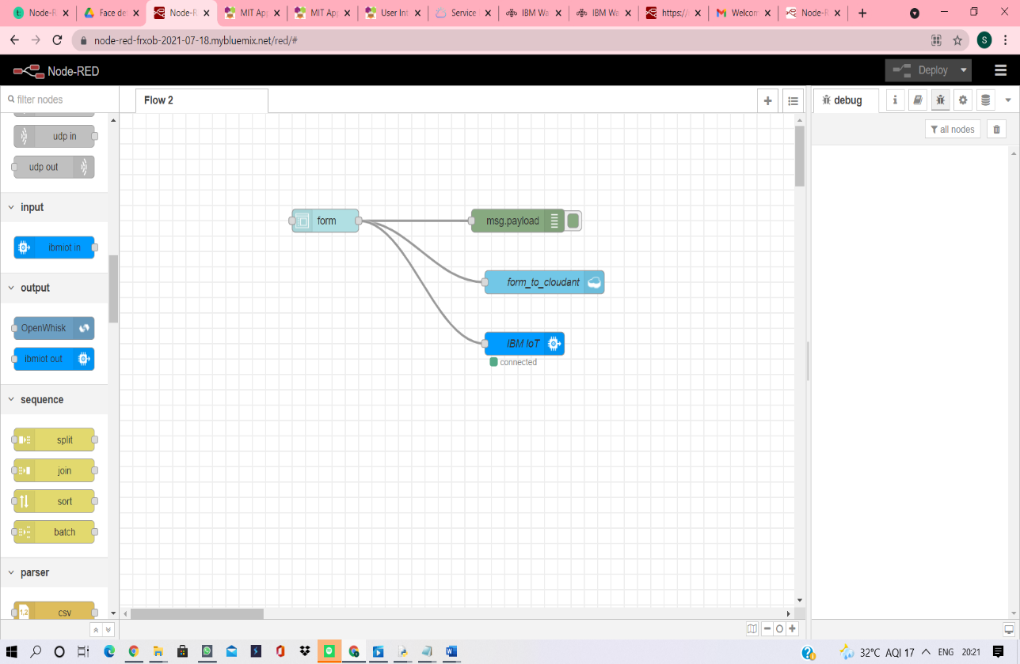

Node-red flow

In the Cloudant DB, a new database with the name “cloudant” will be

formed. Any data (data from “Form” dashboard) sent through the above flow after

deploying the nodes, will be stored as documents in “cloudant” database.

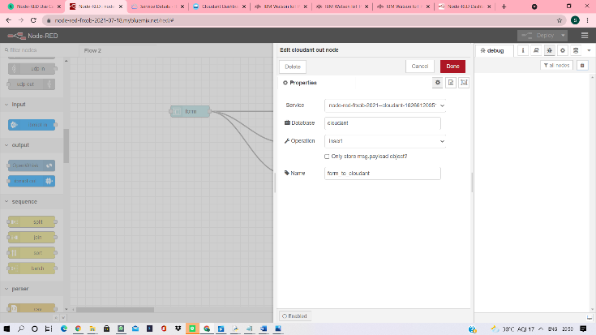

User given input “Date” and “Time” can be stored in:

(1) Format manually typed by the user: Using “Text” type in Form Node

(2) ISO-8601 format: Using “Time” and “Date” type in Form Node

1. Using “Text” type in Form Node

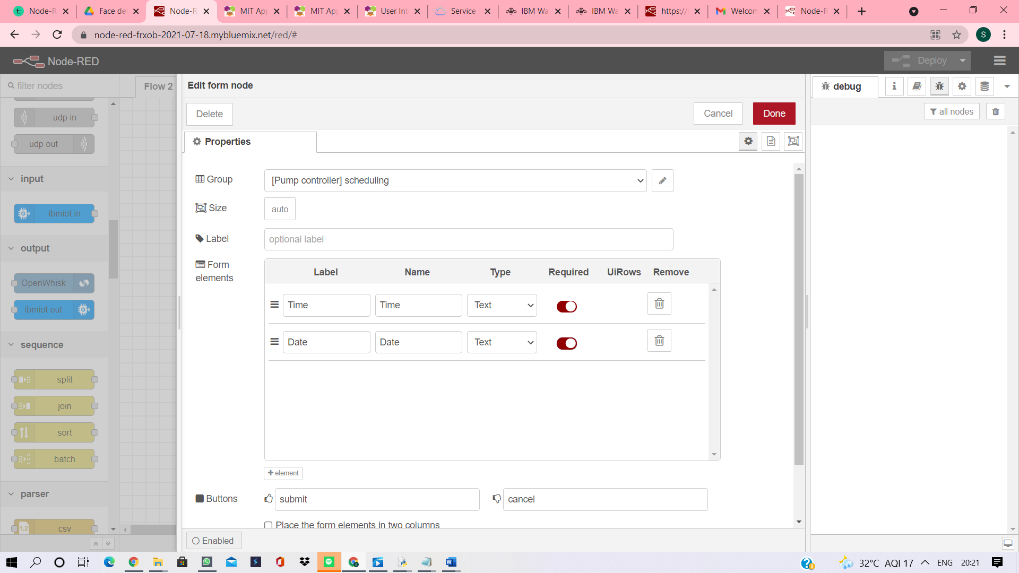

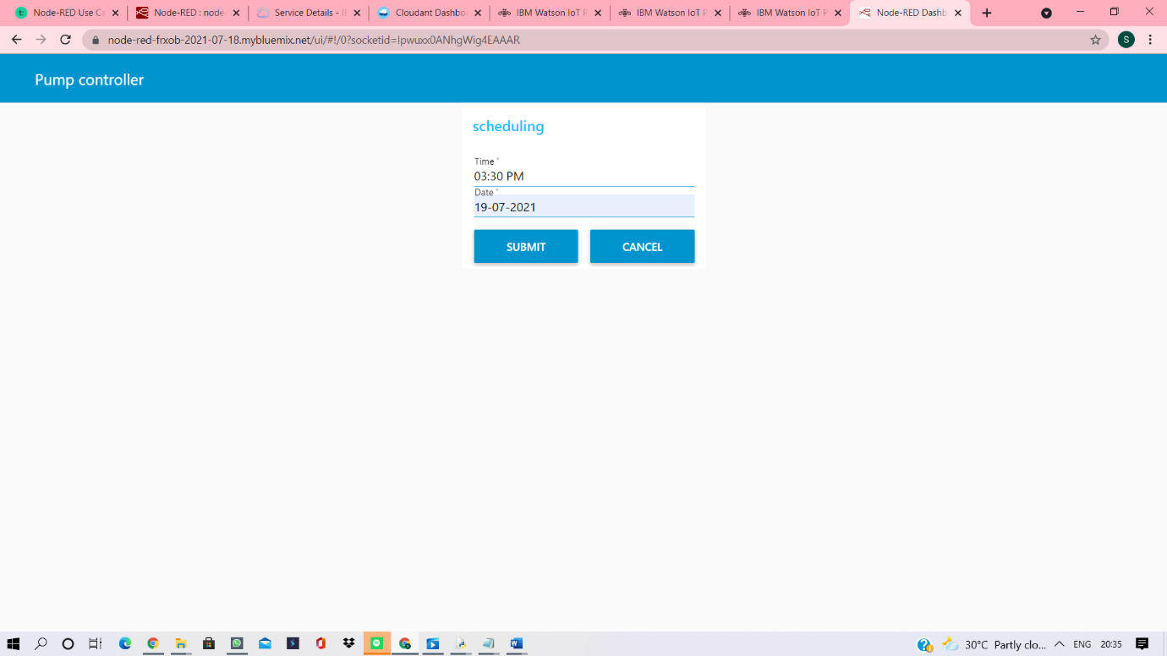

Visualization of manually typed time and data using “Text” type in Form dashboard

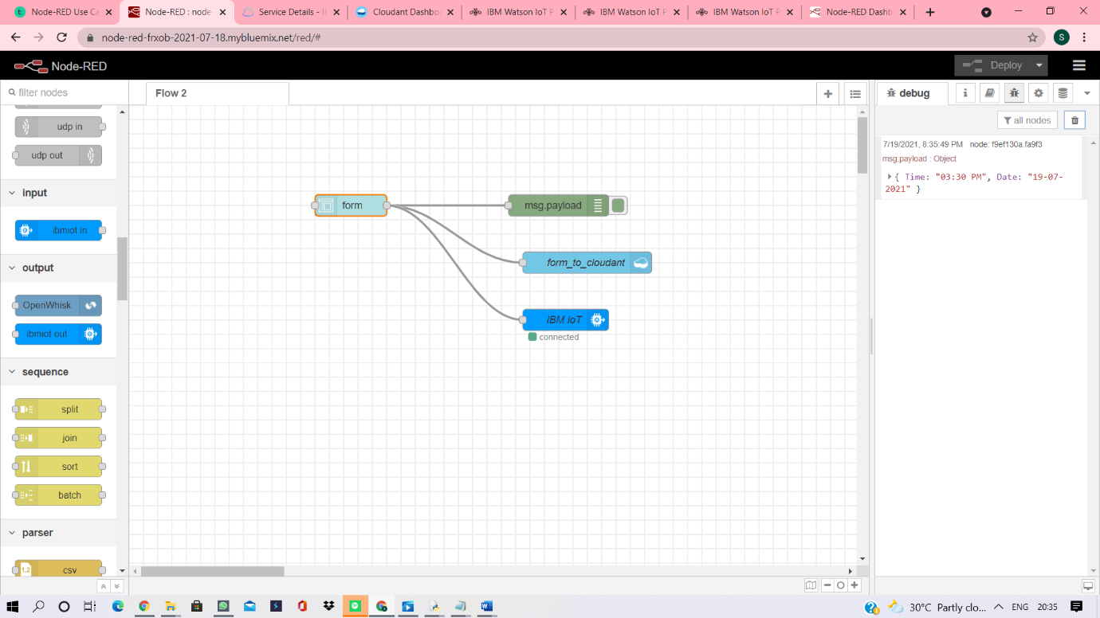

Debug screen of node-red

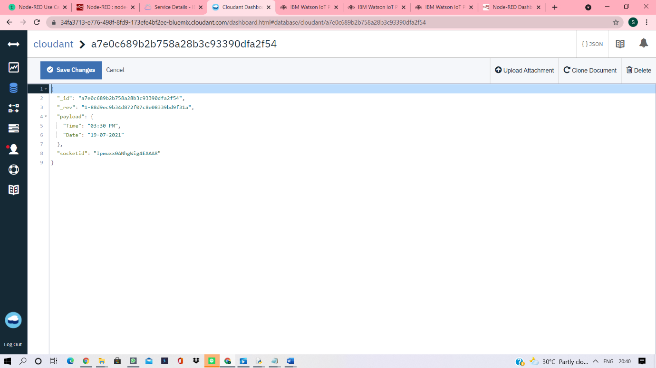

User given data and time stored in cloudant DB

1. Using “Time” and “Date” type in Form Node

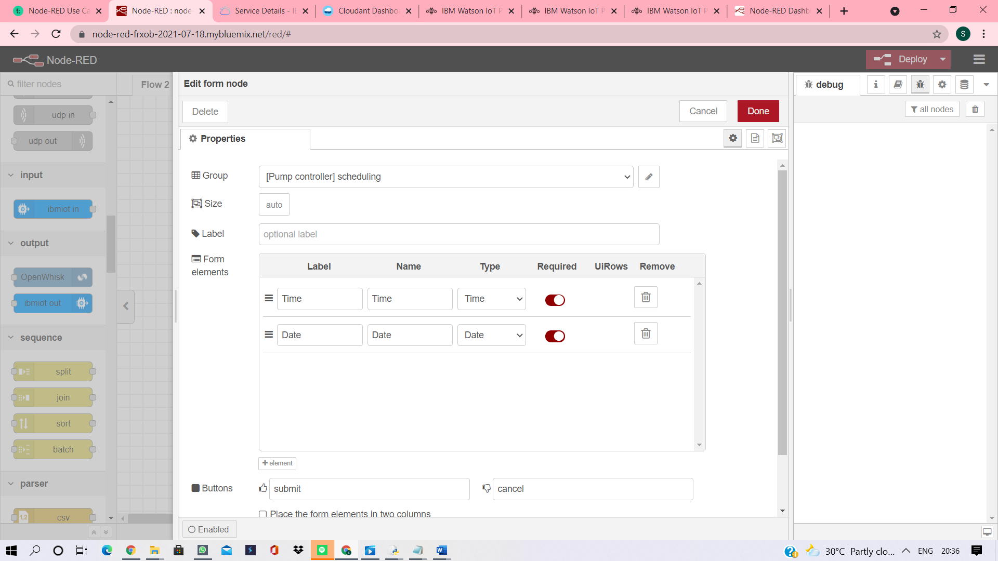

Form node configuration using “Time” And “Date” type

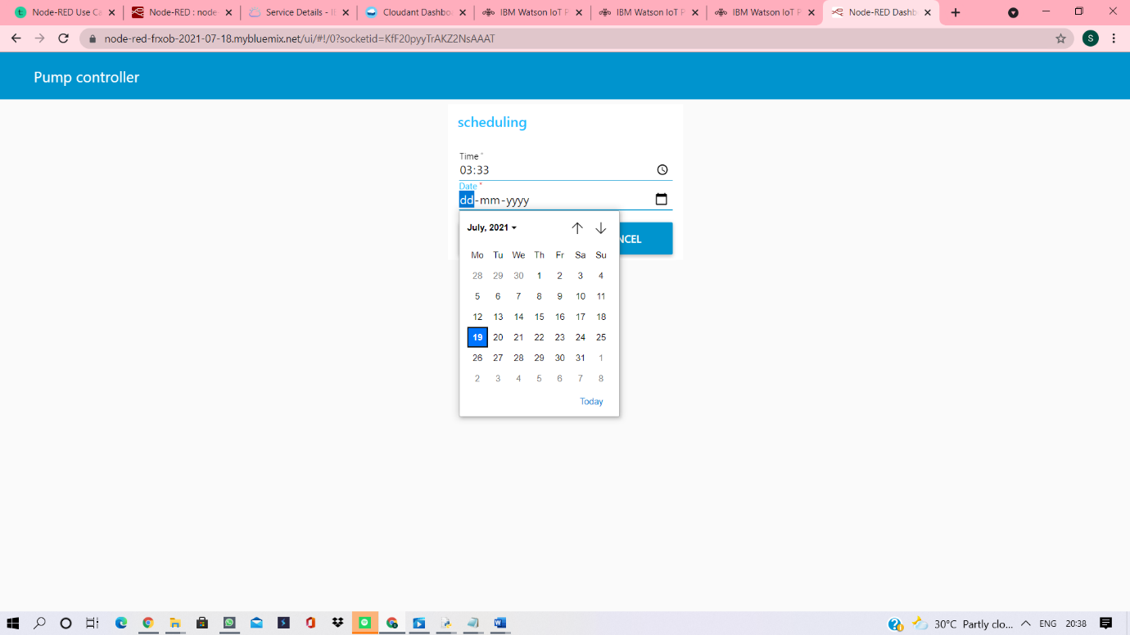

Select time and date

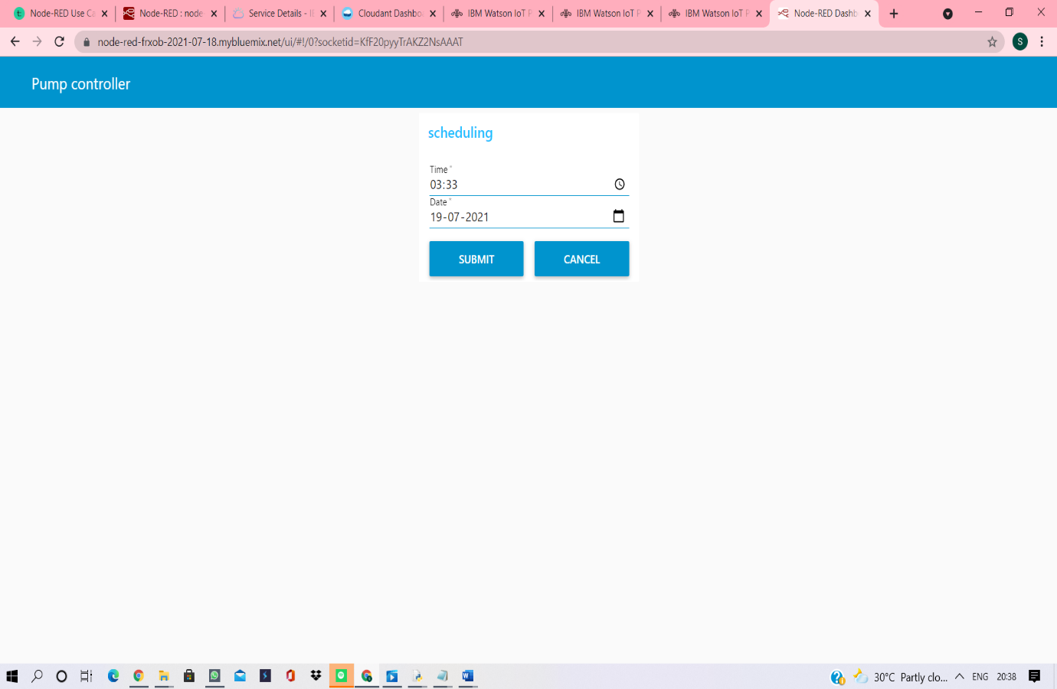

Visualization of time and date input provided

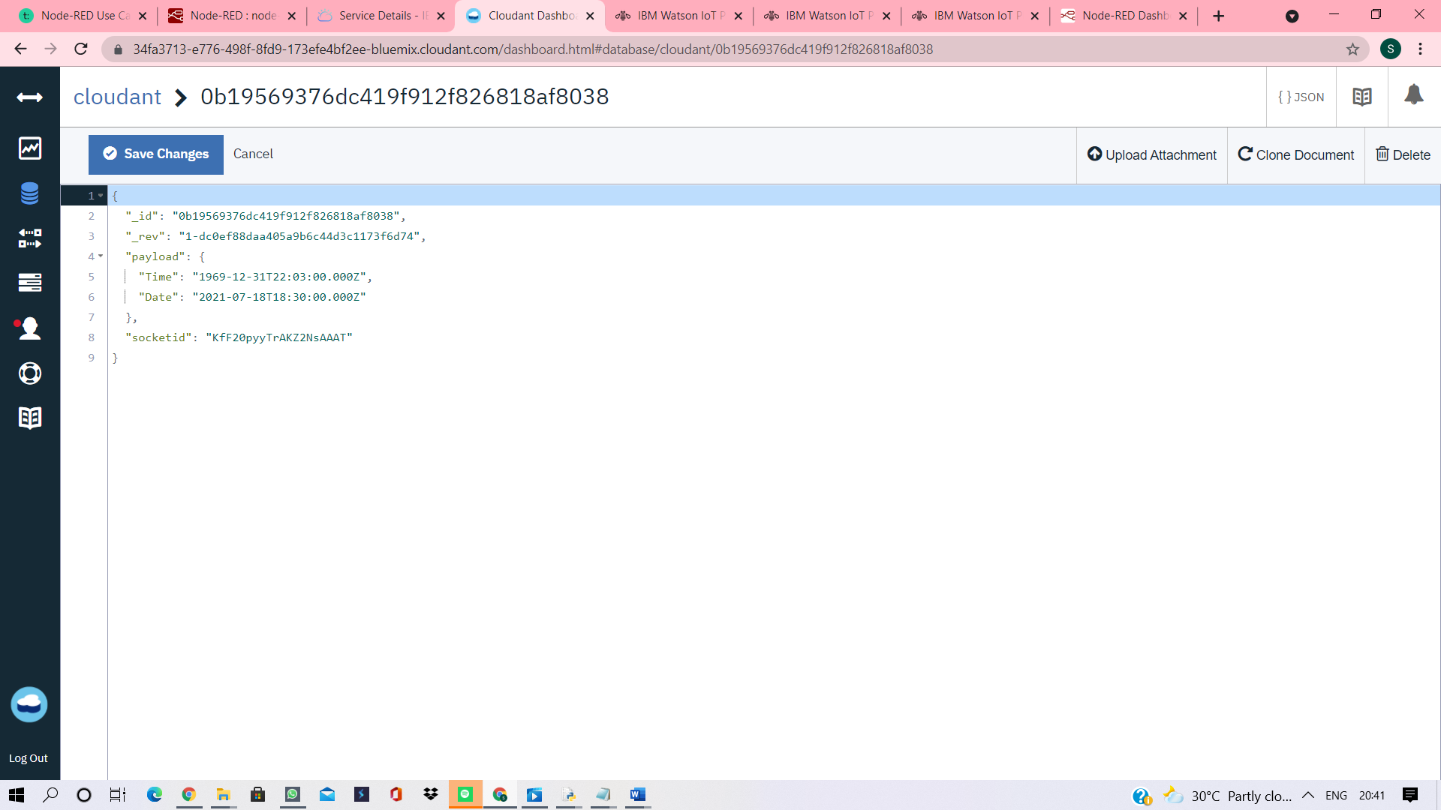

Storing data and time in ISO-8601 format

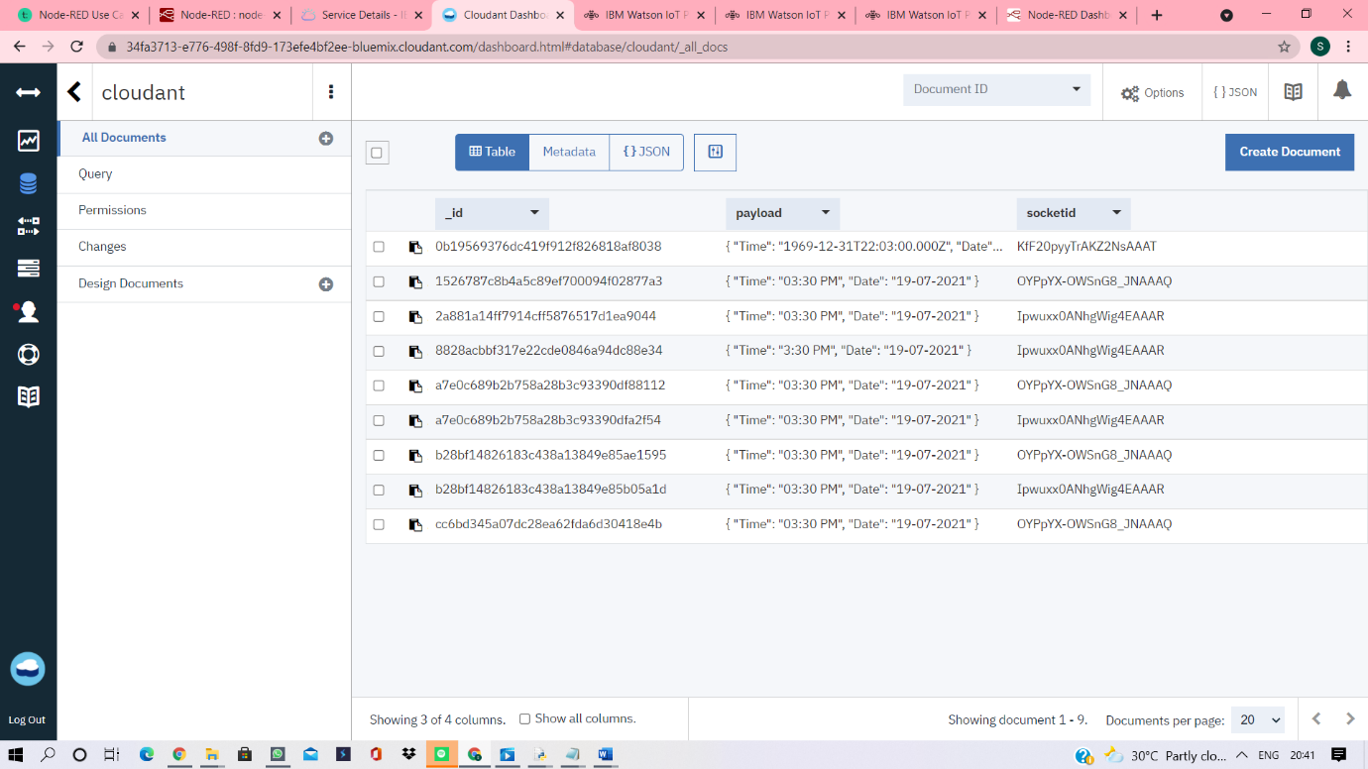

Documents stored in input_to_cloudant database